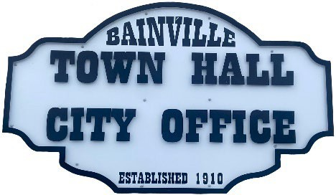Bainville Town Council Meeting Agenda

City Office

211 Clark Ave. East

**Monday January 13, 2025 at 7:00 PM**

* **Call Meeting to Order**
* **Pledge of Allegiance**
* **Roll Call—Establish a quorum.**

Mayor, Toby Romo Councilperson, Will Rathbun

Councilperson, Carol Rasmussen Councilperson, John Gilligan

* **Approval of Agenda***.*
* **Approval of regular meeting minutes dated December 9, 2024.**
* **Treasurers Report**
  1. Cash Balance Report
  2. Bank Reconciliation Report
  3. YTD Expense vs Budget
  4. YTD Revenue vs Budget
  5. Bank Statements for December 2024.
  6. Utility Billing Receipts for December 2024.
  7. Review of delinquent accounts.
  8. Approve claims & JVs in the amount of $45,054.48. Approve voided check #14297 in the amount of $866.37.
  9. Approve payroll in the amount of $6,669.30.
* **Public Comments or Formal Complaints on items not on agenda.**
* **Department or Committee Reports:**
  1. Public Works-
  2. Fire Chief Report-
  3. Roosevelt County Sheriff’s Department Update; Citations:
  4. Committee Reports-
* Cemetery Advisory Committee-
* Bainville Community Development Committee-
* Bainville Community Association-
* **Old Business:** Discuss pay increase for the Bainville Fire Chief, Council Members and Mayor.
* **New Business:**
  1. Building Permits: Kayla Heen-new residence.
  2. Zoning Committee discussion.
  3. Approval to pay Agri Industries & Interstate Engineering for the completion of the new water line in the amount of $172,282.50.

***SEE BACK SIDE***

* **Mayor’s Report:**

1. Water Rights update on old town water well.
2. Water loss was 116,763 gallons at 21%.

**Adjourn: \*\*\***Next Regular Meeting will be Monday February 10th, 2024, 7:00pm. City Office***