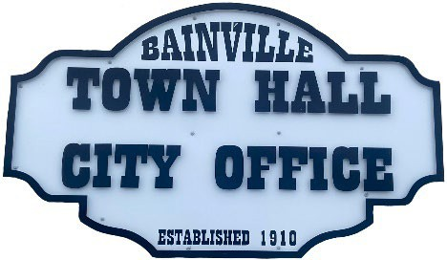Bainville Town Council Meeting Agenda

City Office

211 Clark Ave. East

**Monday October 21st, 2024, 7:00 PM**

* **Call Meeting to Order**
* **Pledge of Allegiance**
* **Roll Call—Establish a quorum.**

Mayor, Toby Romo Councilperson, Will Rathbun

Councilperson, Carol Rasmussen Councilperson, John Gilligan

* **Approval of Agenda***.*
* **Approval of regular meeting minutes dated September 19, 2024.**
* **Treasurers Report**
  1. Cash Balance Report
  2. Bank Reconciliation Report
  3. YTD Expense vs Budget
  4. YTD Revenue vs Budget
  5. Bank Statements for September 2024.
  6. Utility Billing Receipts for September 2024.
  7. Review of delinquent accounts.
  8. Approve claims & JVs in the amount of $50,026.33.
  9. Approve payroll in the amount of $8,354.35.
* **Public Comments or Formal Complaints on items not on agenda.**
* **Department or Committee Reports**
  1. Public Works/Fire Chief Report-
  2. Roosevelt County Sheriff’s Department Update; Citations:
  3. Committee Reports-
* Cemetery Advisory Committee-
* Bainville Community Development Committee:
* **New Business:**
  1. Building Permits: N/A
* **Mayor’s Report:**

1. 2024-25 Annual Budget & Annual Financial Report have both been submitted to the state.
2. Water loss was 420,266 gallons at 30% in September of 2024. *our goal is 10% or less.
3. A major water leak was repaired on October 4th.
4. Park sidewalk will not be completed until next spring.

****SEE BACK SIDE****

1. Budget Summary.
2. Request to release water rights for water well on Dave Granley property.

**Adjourn: \*\*\***Next Regular Meeting will be Monday, November 11, 2024, 7:00pm. City Office***