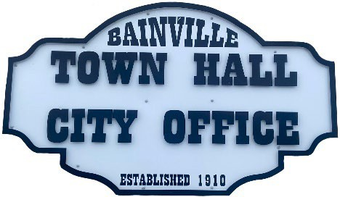
Bainville Town Council Meeting Agenda

City Office

211 Clark Ave. East
Tuesday November 10, 2025, at 7:00 PM

- Call Meeting to Order
- Pledge of Allegiance
- Roll Call—Establish a quorum.
Mayor, Toby Romo Councilperson, Will Rathbun
Councilperson, Carol Rasmussen Councilperson, John Gilligan
- Approval of Agenda.
- Approval of regular meeting minutes dated October 14th, 2025.
- Treasurers Report
  - Cash Balance Report
  - Bank Reconciliation Report
  - YTD Expense vs Budget
  - YTD Revenue vs Budget
  - Bank Statements for October 2025.
  - Utility Billing Receipts for October 2025.
  - Review of delinquent accounts.
  - Approve claims & JVs in the amount of $24,974.78.
  - Approve payroll in the amount of $9,291.45.
- Public Comments or Formal Complaints on items not on agenda.
- Department or Committee Reports:
  - Public Works-
  - Fire Chief Report-
  - Roosevelt County Sheriff’s Department Update-
  - Committee Reports-
- Cemetery Advisory Committee-
- Bainville Community Development Committee-
- Bainville Community Association-
- Old Business:
  - Water/sewer/garbage rate study update-
  - Growth Policy & grant through Interstate Engineering.
  - Discussion on decreasing the speed limit within the town.
  - Budget 2025-2026 is complete & will be submitted to the state for approval.
  - Update on 2025-2026 Annual Financial Report by Chet McLean.

***SEE BACK SIDE***

- New Business:

  - Building Permit-Toby Romo, Permit for garage & bedroom addition at 212 2nd street rental unit.
  - Update on Bainville Softball Field ownership.
  - Clear title for the Town of Bainville office lot.
  - Workmans Compensation program change effective July 1, 2026.
  - Discussion on a donation to the Town of Bainville to purchase an Ice-Skating Rink.

- Mayor’s Report:
- Town complaints-
- Water loss was at 39% for October 2025.

Adjourn:

***Next Regular Meeting will be Monday December 8th, 2025, 7:00pm. City Office***

