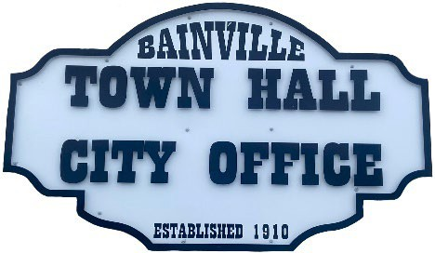Bainville Town Council Meeting Agenda

City Office

211 Clark Ave. East

**Tuesday November 12, 2024, 7:00 PM**

* **Call Meeting to Order**
* **Pledge of Allegiance**
* **Roll Call—Establish a quorum.**

Mayor, Toby Romo Councilperson, Will Rathbun

Councilperson, Carol Rasmussen Councilperson, John Gilligan

* **Approval of Agenda***.*
* **Approval of regular meeting minutes dated October 21, 2024.**
* **Treasurers Report**
  1. Cash Balance Report
  2. Bank Reconciliation Report
  3. YTD Expense vs Budget
  4. YTD Revenue vs Budget
  5. Bank Statements for October 2024.
  6. Utility Billing Receipts for October 2024.
  7. Review of delinquent accounts.
  8. Approve claims & JVs in the amount of $20,120.01.
  9. Approve payroll in the amount of $8,363.60.
* **Public Comments or Formal Complaints on items not on agenda.**
* **Department or Committee Reports**
  1. Public Works/Fire Chief Report-
  2. Roosevelt County Sheriff’s Department Update; Citations:
  3. Committee Reports-
* Cemetery Advisory Committee-
* Bainville Community Development Committee-
* Bainville Community Association-Request to purchase new tables for in the gazebo.
* **New Business:**
  1. Building Permits:
* Dan Lambert-Building Permit for a Connex container.
* Gary & Brianna Brown-Building Permit for a storage shed in backyard.
* **Mayor’s Report:**

1. Recommendation for Town of Bainville Fire Chief.

***SEE BACK SIDE***

1. Request to release water rights for water well on Dave Granley property. Clerk Cochran is researching who the original permit was issued to & the expense of operating & maintaining a private water well.
2. Unpermitted camper being lived in within town limits. Bainville Town Code-4.02.080 Sewer Connections for Trailer Spaces; Permit Required. It shall be unlawful for any person to lease trailer space for sewer or water connections and for occupancy by humans within the town limits unless the owner of such property has, prior to any such connections, received a permit from the town for such connections.
3. Water loss was 500,528 gallons at 47% in October of 2024. *our goal is 10% or less.

**Adjourn: \*\*\***Next Regular Meeting will be Monday, December 9, 2024, 7:00pm. City Office***