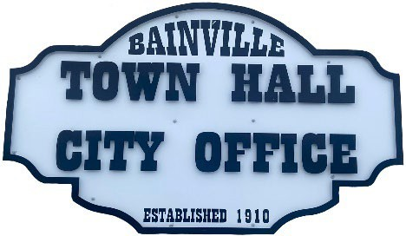Bainville Town Council Meeting Agenda

City Office

211 Clark Ave. East

**Monday December 9, 2024, 7:00 PM**

* **Call Meeting to Order**
* **Pledge of Allegiance**
* **Roll Call—Establish a quorum.**

Mayor, Toby Romo Councilperson, Will Rathbun

Councilperson, Carol Rasmussen Councilperson, John Gilligan

* **Approval of Agenda***.*
* **Approval of regular meeting minutes dated November 12, 2024.**
* **Treasurers Report**
  1. Cash Balance Report
  2. Bank Reconciliation Report
  3. YTD Expense vs Budget
  4. YTD Revenue vs Budget
  5. Bank Statements for November 2024.
  6. Utility Billing Receipts for November 2024.
  7. Review of delinquent accounts.
  8. Approve claims & JVs in the amount of $39,395.35.
  9. Approve payroll in the amount of $7,911.23.
* **Public Comments or Formal Complaints on items not on agenda.**
* **Department or Committee Reports**
  1. Public Works-
  2. Fire Chief Report-
  3. Roosevelt County Sheriff’s Department Update; Citations:
  4. Committee Reports-
* Cemetery Advisory Committee-
* Bainville Community Development Committee-
* Bainville Community Association-
* **New Business:**
  1. Building Permits: None.
  2. Mayor Romo recommends a 4% pay increase for Town of Bainville employees.
  3. Discuss pay increase for Bainville Fire Chief, Council Members and Mayor. They are currently at $30 per town council meeting.
* **Mayor’s Report:**

1. Water Rights update on old town water well.

**Adjourn: \*\*\***Next Regular Meeting will be Monday January 13, 2024, 7:00pm. City Office***