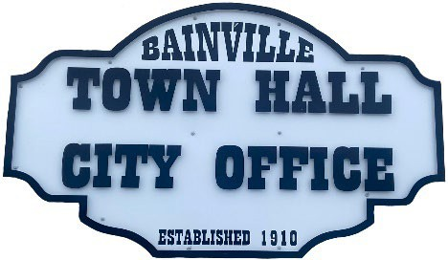Bainville Town Council Meeting Agenda

City Office

211 Clark Ave. East

**Monday February 10, 2025 at 7:00 PM**

* **Call Meeting to Order**
* **Pledge of Allegiance**
* **Roll Call—Establish a quorum.**

Mayor, Toby Romo Councilperson, Will Rathbun

Councilperson, Carol Rasmussen Councilperson, John Gilligan

* **Approval of Agenda***.*
* **Approval of regular meeting minutes dated January 13, 2025.**
* **Treasurers Report**
  1. Cash Balance Report
  2. Bank Reconciliation Report
  3. YTD Expense vs Budget
  4. YTD Revenue vs Budget
  5. Bank Statements for January 2025.
  6. Utility Billing Receipts for January 2025.
  7. Review of delinquent accounts.
  8. Approve claims & JVs in the amount of $24,718.26.
  9. Approve payroll in the amount of $7,298.36.
* **Public Comments or Formal Complaints on items not on agenda.**
* **Department or Committee Reports:**
  1. Public Works-
  2. Fire Chief Report-
  3. Roosevelt County Sheriff’s Department Update; Citations:
  4. Committee Reports-
* Cemetery Advisory Committee-
* Bainville Community Development Committee-
* Bainville Community Association-
* **New Business:**
  1. Building Permits: Tom Romo-Addition to existing building.
  2. Lower Yellowstone Rural Electric bill.
  3. Discussion on consultants for town development.
  4. Funding account for Softball Field.
  5. Water rights lease to Asgard construction.
* **Mayor’s Report:**

1. Water loss was at 19%.

**Adjourn: \*\*\***Next Regular Meeting will be Monday March 10th, 2025, 7:00pm. City Office***