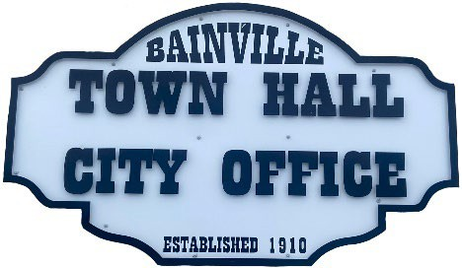
Bainville Town Council Meeting Agenda

City Office

211 Clark Ave. East
Tuesday February 17, 2026 at 7:00 PM

- Call Meeting to Order
- Pledge of Allegiance
- Roll Call—Establish a quorum.
Mayor, Toby Romo Councilperson, Will Rathbun
Councilperson, Carol Rasmussen Councilperson, John Gilligan
- Approval of Agenda.
- Approval of regular meeting minutes dated January 12th, 2025.
- Treasurers Report
  - Cash Balance Report
  - Bank Reconciliation Report
  - YTD Expense vs Budget
  - YTD Revenue vs Budget
  - Bank Statements for January 2026.
  - Utility Billing Receipts for January 2026.
  - Review of delinquent accounts.
  - Approve claims & JVs in the amount of $28,647.96.
  - Approve payroll in the amount of $7,019.07.
- Public Comments or Formal Complaints on items not on agenda.
- Department or Committee Reports:
  - Public Works-
  - Fire Chief Report-
  - Roosevelt County Sheriff’s Department Update-
  - Committee Reports-
- Cemetery Advisory Committee-
- Bainville Community Development Committee-
- Bainville Community Association-
- Old Business:
  - Growth Policy & grant through Interstate Engineering. No updates to date. Waiting to hear on grant approval or denial.
  - Review the current policy on the speed limit within the town. Discussion on new speed limit signs & additional stop & yield signs.
  - Town of Bainville Irrigation Pivot sale update-funds may be used to pay down the sewer loan.
  - Town of Bainville John Deere tractor, mower & attachments sale update-funds may be used to pay down the sewer loan.

***SEE BACK SIDE***

- New Business:
- Approval of advertising for hiring seasonal employees. Applications to be approved or denied at the May 2026 Town Council meeting.
- Town loan reviews-The Town has 3 water loans & 1 sewer loan-
      - Water Main Replacement Loan:
      - Current Balance-$80,000
      - Annual Payment-$10,050
      - Final Loan Payment Date- 1/01/2035
      - Water System Improvement Loan:
      - Current Balance-$188,000
      - Annual Payment-$20,800
      - Final Loan Payment Date-7/01/2036
      - Town of Bainville Refinance Loan:
      - Current Balance-$155,000
      - Annual Payment-$14,937.50
      - Final Loan Payment Date-1/01/2038
      - USDA Rural Development Sewer Loan:
      - Current Balance-$172,716.02
      - Annual Payment-$16,848.00
      - Final Loan Payment Date-10/01/2039
- Mayor’s Report:
- Town complaints-
- One of the commercial water meters was recording in “tenths” rather than “actual” gallons, causing a false water loss of up to 500,000 gallons in some months.
- Water loss was at 17% for January 2026.

Adjourn:

***Next Regular Meeting will be Monday March 9th, 2026, 7:00pm. City Office***

