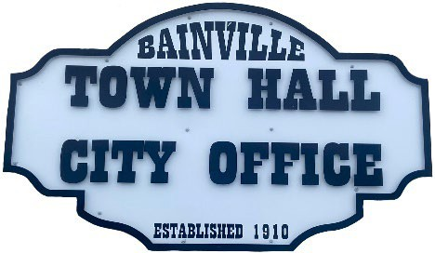Bainville Town Council Meeting Agenda

City Office

211 Clark Ave. East

**Monday March 10, 2025 at 7:00 PM**

* **Call Meeting to Order**
* **Pledge of Allegiance**
* **Roll Call—Establish a quorum.**

Mayor, Toby Romo Councilperson, Will Rathbun

Councilperson, Carol Rasmussen Councilperson, John Gilligan

* **Approval of Agenda***.*
* **Approval of regular meeting minutes dated February 10, 2025.**
* **Treasurers Report**
  1. Cash Balance Report
  2. Bank Reconciliation Report
  3. YTD Expense vs Budget
  4. YTD Revenue vs Budget
  5. Bank Statements for February 2025.
  6. Utility Billing Receipts for February 2025.
  7. Review of delinquent accounts.
  8. Approve claims & JVs in the amount of $32,416.80.
  9. Approve payroll in the amount of $6,566.80.
* **Public Comments or Formal Complaints on items not on agenda.**
* **Department or Committee Reports:**
  1. Public Works- Dan Lambert will be presenting bids for concrete, electrical, and spray foam insulation for the east side shop at the lagoon. Dan Lambert also has bids for a broom attachment.
  2. Fire Chief Report-
  3. Roosevelt County Sheriff’s Department Update; Citations:
  4. Committee Reports-
* Cemetery Advisory Committee-
* Bainville Community Development Committee-
* Bainville Community Association-
* **New Business:**
  1. Building Permits: N/A
  2. Water Agreement with Asgard update.
  3. Cemetery addition deed update. Berwick family donated the land for the addition to the Town of Bainville.
* **Mayor’s Report:**

1. Discuss selling the irrigation pivot.
2. Water loss was at 8.8%.

**Adjourn: \*\*\***Next Regular Meeting will be Monday April 14th, 2025, 7:00pm. City Office***