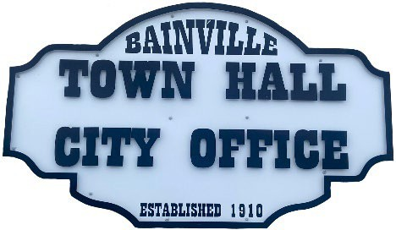
Bainville Town Council Meeting Agenda City Office

211 Clark Ave. East
Monday March 11, 2024, 7:00 PM

- Call Meeting to Order
- Pledge of Allegiance
- Roll Call—Establish a quorum.
Mayor, Toby Romo Councilperson, Will Rathbun
Councilperson, Carol Rasmussen Councilperson, John Gilligan
- Approval of Agenda.
- Approval of regular meeting minutes dated February 12, 2024.
- Treasurers Report
  - Cash Balance Report
  - Bank Reconciliation Report
  - YTD Expense vs Budget
  - YTD Revenue vs Budget
  - Bank Statements for February 2024.
  - Utility Billing Receipts for February 2024.
  - Review delinquent accounts.
  - Approve claims & JVs in the amount of $18,422.25.
  - Approve payroll in the amount of $8,882.06.
- Public Comments or Formal Complaints on items not on agenda.
- Department or Committee Reports
  - Public Works/Fire Chief Report
    - Water project update.
  - Roosevelt County Sheriff’s Department Update; Citations.
  - Committee Reports.
- Public Hearing
- New Business:
  - Building Permits:
  - Sidewalk Policy recommendations.
  - Water Re-connect fee recommendations.
  - Speed Limit sign request on 7th Ave E.
  - Seasonal workers: review job description, (mow & maintain Cemetery).
- Advertise Cemetery positions.
  - Attorney recommendations for failure to obtain a building permit.
- Mayor’s Report:
- Update on Employee Policy Manual.
- Codification.
- Water loss was 69,855 gallons at 14% in February of 2024. *our goal is 10% or less.
- Town Council Action Items:

- Adjourn
***Next Regular Meeting will be Monday, April 8th, 2024, 7:00pm. City Office***

