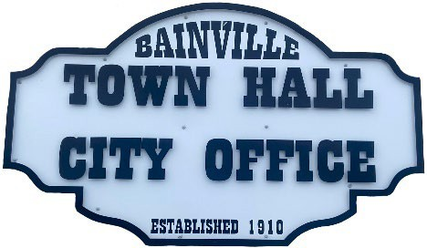
Bainville Town Council Meeting Agenda

City Office

211 Clark Ave. East
Monday March 9, 2026 at 7:00 PM

- Call Meeting to Order
- Pledge of Allegiance
- Roll Call—Establish a quorum.
Mayor, Toby Romo Councilperson, Will Rathbun
Councilperson, Carol Rasmussen Councilperson, John Gilligan
- Approval of Agenda.
- Approval of regular meeting minutes dated February 17th, 2026.
- Treasurers Report
  - Cash Balance Report
  - Bank Reconciliation Report
  - YTD Expense vs Budget
  - YTD Revenue vs Budget
  - Bank Statements for February 2026.
  - Utility Billing Receipts for February 2026.
  - Review of delinquent accounts.
  - Approve claims & JVs in the amount of $26,320.90. Approval to void check #14781 for $1,000.00.
  - Approve payroll in the amount of $6,549.62.
- Public Comments or Formal Complaints on items not on agenda.
- Department or Committee Reports:
  - Public Works-
  - Fire Chief Report-
  - Roosevelt County Sheriff’s Department Update-
  - Committee Reports-
- Cemetery Advisory Committee-
- Bainville Community Development Committee-
- Bainville Community Association-
- Old Business:
  - Growth Policy & grant through Interstate Engineering. No updates to date.
  - Review the updated bid for seamless gutters on the Lagoon shop buildings.

- New Business:
- Set a reserve amount for the sale of the Town of Bainville Irrigation Pivot & John Deere Tractor, mower & attachments.
- Approval to transfer the Bainville Softball Field fund from the Bainville Community Association to the Town of Bainville.

***Please see back side***

Mayor’s Report:
- Town complaints-
- Update on Animal Policy enforcement.
- Water loss was 41% (269,157 gallons) for February 2026.

Adjourn:

***Next Regular Meeting will be Monday April 13th, 2026, 7:00pm. City Office***

