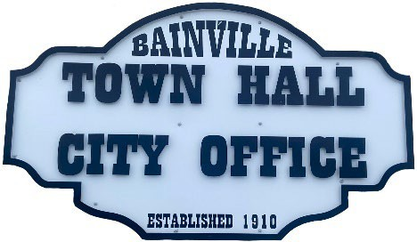
Bainville Town Council Meeting Agenda

City Office

211 Clark Ave. East
Monday April 13, 2026 at 7:00 PM

- Call Meeting to Order
- Pledge of Allegiance
- Roll Call—Establish a quorum.
Mayor, Toby Romo Councilperson, Will Rathbun
Councilperson, Carol Rasmussen Councilperson, John Gilligan
- Approval of Agenda.
- Approval of regular meeting minutes dated March 9, 2026.
- Treasurers Report
  - Cash Balance Report
  - Bank Reconciliation Report
  - YTD Expense vs Budget
  - YTD Revenue vs Budget
  - Bank Statements for March 2026.
  - Utility Billing Receipts for March 2026.
  - Review of delinquent accounts.
  - Approve claims & JVs in the amount of $. Approval to void checks #14775 for $1,705.81, #14776 for $1,630.83, & #14777 for $1,100.94.
  - Approve payroll in the amount of $.
- Public Comments or Formal Complaints on items not on agenda.
- Department or Committee Reports:
  - Public Works-
  - Fire Chief Report-
  - Roosevelt County Sheriff’s Department Update- In March 2026, there were (11) calls for service, (0) arrests, & (3) citations.
  - Committee Reports-
- Cemetery Advisory Committee-
- Bainville Community Development Committee-
- Bainville Community Association-
- Old Business:
  - Growth Policy & grant through Interstate Engineering. John Bach with Interstate Engineering will be present to discuss the CDBG Growth Policy updates. It is recommended that the Growth Policy be updated every 5 years. Up to date Growth Policies increase chances of getting grants approved. The town applied for and was rewarded a CDBG grant for the preparation of a growth policy update. The CDBG grants are for up to $50,000 with a 25% match required, so the total project would be $62,500. The grant application- cost $2,500 to prepare, which is out of pocket for the Town.
***Please see back side***

  - Town of Bainville Irrigation Pivot-update on a sealed bid.
  - Seasonal help job openings available. Applications should be submitted to the town office before May 1, 2026.
  - Transfer funds from Bainville Community Association to the Town of Bainville. See table below:

Fund Transfers from Bainville Community Association to the Town of Bainville
Committee/Organization Name | Amount to be Transferred | Town of Bainville Fund | Town of Bainville Account
Softball Field Donations | $7,500.00 | General Fund (1000) | Parks & Recreation Services-460400
Former Main Street Restoration Committee | $11,246.00 | General Fund (1000) | Parks & Recreation Services-460400
Bainville Cemetery Committee | $9,984.48 | General Fund (1000) | Cemetery Services 430900

- New Business:
- Accept resignation from Councilperson Will Rathbun.
- Approval to advertise for a replacement councilperson to serve for the remainder of Will Rathbuns term. Term expires December 31, 2027.
- Tom Romo Building Permit-Construction permit for an addition on the north side of the house at 511 Evans Street.

Mayor’s Report:
- Town complaints-
- Review the Town of Bainville Cemetery Policy.
- Town of Bainville maintenance needs.
- Approval of creating and appointing a committee for the Bainville Softball Field.
- Discussion on employee pay increase.
- Water loss was 26% (154,671 gallons) for March 2026.

Adjourn:

***Next Regular Meeting will be Monday April 13th, 2026, 7:00pm. City Office***

