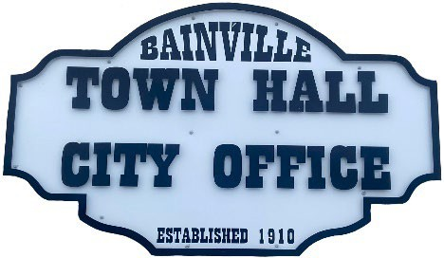Bainville Town Council Meeting Agenda

City Office

211 Clark Ave. East

**Monday April 14, 2025 at 7:00 PM**

* **Call Meeting to Order**
* **Pledge of Allegiance**
* **Roll Call—Establish a quorum.**

Mayor, Toby Romo Councilperson, Will Rathbun

Councilperson, Carol Rasmussen Councilperson, John Gilligan

* **Approval of Agenda***.*
* **Approval of regular meeting minutes dated March 10, 2025.**
* **Treasurers Report**
  1. Cash Balance Report
  2. Bank Reconciliation Report
  3. YTD Expense vs Budget
  4. YTD Revenue vs Budget
  5. Bank Statements for March 2025.
  6. Utility Billing Receipts for March 2025.
  7. Review of delinquent accounts.
  8. Approve claims & JVs in the amount of $.
  9. Approve payroll in the amount of $6,896.44.
* **Public Comments or Formal Complaints on items not on agenda.**
* **Department or Committee Reports:**
  1. Public Works- Update on new broom attachment. Progress report on Hill Ave development. Gravel price comparison.
  2. Fire Chief Report-
  3. Roosevelt County Sheriff’s Department Update-Report included 13 calls for service, 1 arrest & 4 citations.
  4. Committee Reports-
* Cemetery Advisory Committee-
* Bainville Community Development Committee-
* Bainville Community Association-
* **New Business:**
  1. Building Permits: Kayla Heen-storage shed. Elijah Romo-fence.
  2. Advertise for summer help & cemetery maintenance.
  3. Softball Field trade with First English Lutheran Church.
  4. Mineral Rights gift to the town from a local family.
  5. Playground equipment possibilities.
  6. Light pole decorations for holidays & seasonal changes.
  7. Community Service Workers.
* **Mayor’s Report:**

1. Mayor, Council members & Fire Chief stipend is currently $30/per meeting.
2. Water loss was at 8% for March 2025.

**Adjourn: \*\*\***Next Regular Meeting will be Monday May 12th, 2025, 7:00pm. City Office***