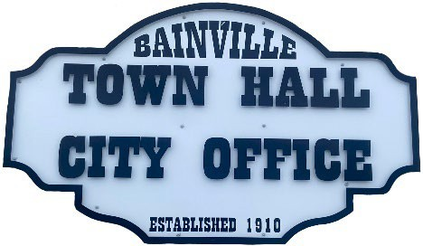
Bainville Town Council Meeting Agenda

City Office

211 Clark Ave. East
Monday May 11, 2026 at 7:00 PM

- Call Meeting to Order
- Pledge of Allegiance
- Roll Call—Establish a quorum.
Mayor, Toby Romo Councilperson,
Councilperson, Carol Rasmussen Councilperson, John Gilligan
- Approval of Agenda.
- Approval of regular meeting minutes dated April 13, 2026.
- Treasurers Report
  - Cash Balance Report
  - Bank Reconciliation Report
  - YTD Expense vs Budget
  - YTD Revenue vs Budget
  - Bank Statements for April 2026.
  - Utility Billing Receipts for April 2026.
  - Review of delinquent accounts.
  - Approve claims & JVs in the amount of $24,143.54.
  - Approve payroll in the amount of $6,733.08.
- Public Comments or Formal Complaints on items not on agenda.
- Department or Committee Reports:
  - Public Works-
  - Fire Chief Report-
  - Roosevelt County Sheriff’s Department Update- In April 2026, there were (18) calls for service, (3) arrests, & (2) citations.
  - Committee Reports-
- Cemetery Advisory Committee-
- Committee recommends purchasing a new fence for the front of the cemetery.
- Bainville Community Development Committee-
- Bainville Community Association-
- Bainville Softball Committee-
- Old Business:
  - Town of Bainville Irrigation Pivot & pivot pump- Set a reserve price for the irrigation pivot & pivot pump that has been approved for a sealed bid by the Bainville Town Council.
  - Seasonal help job openings available-Review the submitted applications.
  - Hire Seasonal employees.

***PLEASE SEE BACK SIDE***

  - Update on Growth Policy-The Requests for Qualifications & Master Service Agreement are currently being advertised in the Northern Plains Independent newspaper.
  - Employee pay increase.

- New Business:
- Building Permit-Jason & Tristain Eveland-Permit for a new fence & 8’x10’ shed.
- Appoint a new Councilperson to fill previous Councilperson Will Rathbun’s seat. Term expires December 31,2027.
- Approval to remove Will Rathbun as a signer for the Town of Bainville at Opportunity Bank of America in Culbertson, Montana.
- Elect a President of The Town of Bainville Council. (President will act as Chairperson in absence of Mayor & will be authorized to sign checks other documents).
- Approval for the newly appointed Bainville Town Council President to become a signer for the Town of Bainville at Opportunity Bank of America in Culbertson, Montana.
- Approval to advertise for a Notice of Sealed Bids for the (4) Town of Bainville items-1981 John Deere Tractor, John Deere 8’ flail mower attachment, irrigation pivot & irrigation pump. Notice of Sealed Bids will be advertised for 2 weeks prior to bid deadline.
- Review quote from Seitz Insurance for Montana State Fund Workman’s Compensation Program.

Mayor’s Report:
- Town complaints-
- Budget Review
- Town of Bainville maintenance needs-
- Review quotes for new riding lawn mower.
- Bainville Park sidewalk safety concerns.
- Approval to paint/stain the gazebo in the town park.
- Approval of purchasing (4) new tables for inside the gazebo.
- Water loss was % ( gallons) for April 2026.

Adjourn:

***Next Regular Meeting will be Monday June 8, 2026, 7:00pm. City Office***

