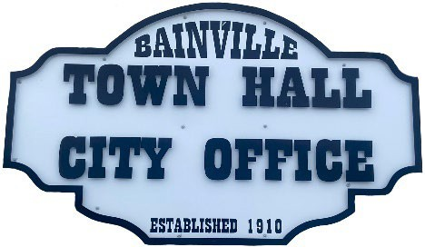
Bainville Town Council Meeting Agenda

City Office

211 Clark Ave. East
Monday June 10, 2024, 7:00 PM

- Call Meeting to Order
- Pledge of Allegiance
- Roll Call—Establish a quorum.
Mayor, Toby Romo Councilperson, Will Rathbun
Councilperson, Carol Rasmussen Councilperson, John Gilligan
- Approval of Agenda.
- Approval of regular meeting minutes dated May 13, 2024.
- Treasurers Report
  - Cash Balance Report
  - Bank Reconciliation Report
  - YTD Expense vs Budget
  - YTD Revenue vs Budget
  - Bank Statements for May 2024.
  - Utility Billing Receipts for May 2024.
  - Review delinquent accounts.
  - Approve claims & JVs in the amount of $46,428.86.
  - Approve payroll in the amount of $11,407.54.
- Public Comments or Formal Complaints on items not on agenda.
- Department or Committee Reports
  - Public Works/Fire Chief Report-Update on Water Project, DEQ approval.
  - Roosevelt County Sheriff’s Department Update; Citations.
  - Bainville Community Development Committee-Committee held a meeting on May 15th, 2024. Meeting minutes are included in the meeting packet.
  - Committee Reports-
- Cemetery Advisory Committee-
- New Business:
  - Building Permits:
- Scot Folda-Permit for new fence and permit for new sidewalk.
- Coltyn Thomas-Permit for a structure for keeping animals.
- Bainville Faith Fellowship.
  - Cemetery plot price increase.
  - Town has opportunity to own softball field & make improvements, i.e., parking, maintenance, public bathroom/concessions.
- Mayor’s Report:
- Codification-Mayor Romo and Clerk Cochran met with Laura Christofferson on April 10th for a review of city policy. Recommended changes are attached. This meeting will be considered the second of two readings that are required to amend the changes.
- Zoning Plans.
- Mayor Romo’s recommendation for School Liaison.
- Water loss was 82,295 gallons at 15% in May of 2024. *our goal is 10% or less.

Adjourn: ***Next Regular Meeting will be Monday, July 8th, 2024, 7:00pm. City Office***

