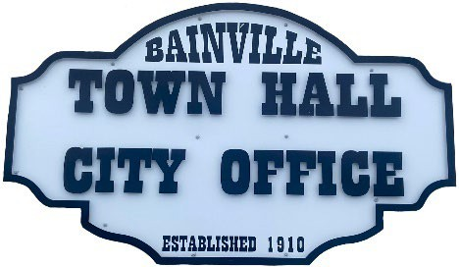Bainville Town Council Meeting Agenda

City Office

211 Clark Ave. East

**Monday July 8th, 2024, 7:00 PM**

* **Call Meeting to Order**
* **Pledge of Allegiance**
* **Roll Call—Establish a quorum.**

Mayor, Toby Romo Councilperson, Will Rathbun

Councilperson, Carol Rasmussen Councilperson, John Gilligan

* **Approval of Agenda***.*
* **Approval of regular meeting minutes dated June 10, 2024.**
* **Treasurers Report**
  1. Cash Balance Report
  2. Bank Reconciliation Report
  3. YTD Expense vs Budget
  4. YTD Revenue vs Budget
  5. Bank Statements for June 2024.
  6. Utility Billing Receipts for June 2024.
  7. Review delinquent accounts.
  8. Approve claims & JVs in the amount of $47,230.22.
  9. Approve payroll in the amount of $10,076.15.
* **Public Comments or Formal Complaints on items not on agenda.**
* **Department or Committee Reports**
  1. Public Works/Fire Chief Report-Update on Water Project, Reimbursement #3. Bids to purchase a Brush Mower for Lagoon & other Town owned properties.
  2. Roosevelt County Sheriff’s Department Update; Citations.
  3. Committee Reports-
* Cemetery Advisory Committee-Clerk Cochran is working on a Resolution and Ordinance to set the new plot price.
* Bainville Community Development Committee-Clean Up Day Flyer was sent with the Utility Bills this month. Their next meeting will be held July 10th at 4:00p.m. at Town Hall.
* **New Business:**
  1. Building Permits:
* Bainville Faith Fellowship.
* Gary & Brianna Brown.
* **Mayor’s Report:**

1. Water Pipeline Easement with Sanfield Developments, LLC. from Laura Christoffersen.
2. Water loss was 154,716 gallons at 16% in June of 2024. *our goal is 10% or less.

**Adjourn: \*\*\***Next Regular Meeting will be Monday, August 12, 2024, 7:00pm. City Office***